Question 4

1. UML Class Diagram  
   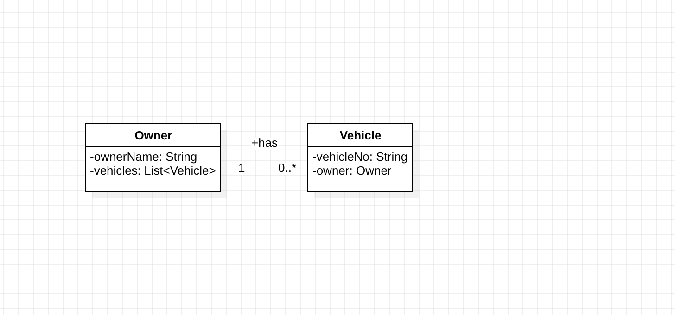

Question 7

1. Use case diagram for Hotel Reservation System

